EX NO: 10 | CALCULATION OF PROCESSING GAIN AND GENERATION OF PN SEQUENCES FOR SPREAD SPECTRUM COMMUNICATION USING MATLAB SIMULATION
Date:

Objectives

i) To calculate the processing gain for various PN sequence lengths and tabulate the corresponding processing gain values.
ii) To visualize and compare the processing gain obtained for different PN sequence lengths using MATLAB plots and analyze the effect of sequence length on spread spectrum performance.

PROGRAM (MATLAB Code)
clc;
clear;
close all;
% PN sequence lengths
PN_length = [7 15 31 63 127 255 511 1023];
% Processing Gain (Linear)
PG_linear = PN_length;
% Processing Gain in dB
PG_dB = 10*log10(PG_linear);
% Display table
T = table(PN_length',PG_dB',...
'VariableNames',{'PN_Length','Processing_Gain_dB'});
disp('Processing Gain Table');
disp(T);
% Plot
figure;
stem(PN_length,PG_dB,'filled');
grid on;
xlabel('PN Sequence Length');
ylabel('Processing Gain (dB)');
title('Spread Spectrum: Processing Gain vs PN Sequence Length');

Objective 1:

To calculate the processing gain for various PN sequence lengths and tabulate the corresponding values.

Procedure
1. Open MATLAB and create a new script file.
2. Initialize the MATLAB workspace using clc, clear, and close all.
3. Define the PN sequence lengths.
4. Calculate the processing gain in linear scale.
5. Convert the processing gain into decibels.
6. Create a table containing PN sequence lengths and corresponding processing gains.
7. Display the table in the MATLAB command window.
8. Observe the variation in processing gain for different PN sequence lengths.

Tabulation
PN Sequence Length | Processing Gain (dB)
7 | 8.45
15 | 11.76
31 | 14.91
63 | 17.99
127 | 21.04
255 | 24.07
511 | 27.08
1023 | 30.10

Result
The processing gain values for different PN sequence lengths were calculated successfully. It was observed that the processing gain increased as the PN sequence length increased.
Objective 2:

To visualize and compare the processing gain obtained for different PN sequence lengths using MATLAB plots.

Procedure
1. Create a figure window in MATLAB.
2. Plot the PN sequence length on the x-axis.
3. Plot the processing gain in dB on the y-axis.
4. Use the stem() function to display discrete processing gain values.
5. Label the axes and provide a suitable title.
6. Enable the grid for better visualization.
7. Compare the processing gain values corresponding to different PN sequence lengths.
8. Observe the trend between PN sequence length and processing gain.

Output
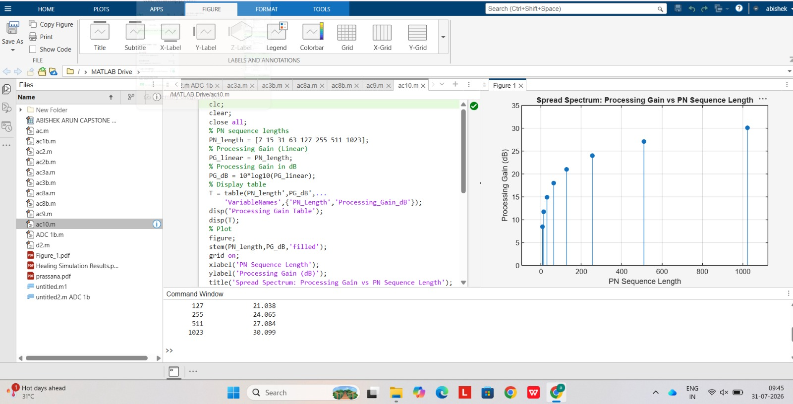

Fig. Processing Gain versus PN Sequence Length
The graph shows that the processing gain increases with PN sequence length. The increase follows a logarithmic trend because the processing gain is proportional to 10 log10(N).

Result
The MATLAB plot successfully illustrated the relationship between PN sequence length and processing gain. Longer PN sequences produced higher processing gains, thereby improving interference rejection and communication reliability.

